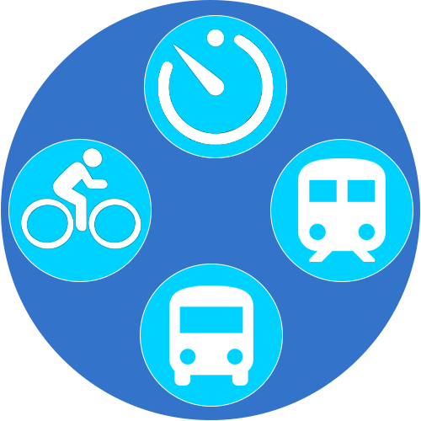

**My Journey App**

**By**

**Linda Veloso**

**C16349876**

**Submitted in partial fulfilment of the requirements for the degree of**

**B.Sc. in Business Computing**

**Dublin Institute of Technology**

**Year 4**

**Supervised by – Audrey Jennings**

**May 2020**

**Declaration**

**This is an original work. All References and assistance are acknowledged.**

**Signed: ____________________________**

**Date: _______________________________**

**Acknowledgements**

This is an opportunity for me to give a big thanks to all those who have helped me through the completion of development of My Journey App.

Thank you to Audrey Jennings my project supervisor who was there through the beginning and end of the development of my project. I admire her positive attitude during the duration of the development process.

Many Thanks to Catherine Higgins my second reader and the other lectures.

Finally, I want to thank my family and Emmanuel who have supported throughout my 4 years in DT354.

Thank you, Linda.

**Table of Contents**

Chapter 1 – Introduction

Chapter 2 – Requirements Capture and Analysis

2.1 Use Case

2.2 Business Actors

2.2 Requirements Analysis

Chapter 3 – Design

Chapter 4 – Implementation

3.1 Technologies Used

3.2 API’s and Libraries Used

3.3 Map Implementation

3.4 Dublin Bus services Implementation

3.5 Luas services and Irish Rail services Implementation

3.6 Favorites

Chapter 5 Test Plan

5.1 Test Plan

Chapter 6 – References

**Chapter 1- Introduction**

**Journey App is an android application, solely based on the travel industry in Ireland and Bus Transportation in Dublin.**

**The Travel Industry under Transportation includes services related abiding by the needs of people when moving from one location to another.**

**This application is to help users get to their desired location with accurate information, using Realtime information provided by a reliable API and a user-enabled Map feature to pinpoint where you are and what form of transport is near you.**

**This application is intended to be a quick and easy application that would cater to children, adults as well as the elderly here in Ireland.**

**As Timetables are the old-fashioned way to gather information the Journey App embraces Technology and implements it a different way.**

**Makes taking transportation much easier, with the click of a finger the information you would need to get to A to B would be easily accessed on your mobile device without having to switch between other applications which wastes time.**

**Rich in information for the user, this application provides the most accurate real-time information, because it uses the most reliable API’s provided by the government.**

**There is no application in the App Store or Google Play that offer the same features, of offering Realtime information as well as directions all in one mobile application so my aim in this project is to offer this feature to users.**

**Chapter 2 – Requirements Capture and Analysis**

**2.1. Use Case**

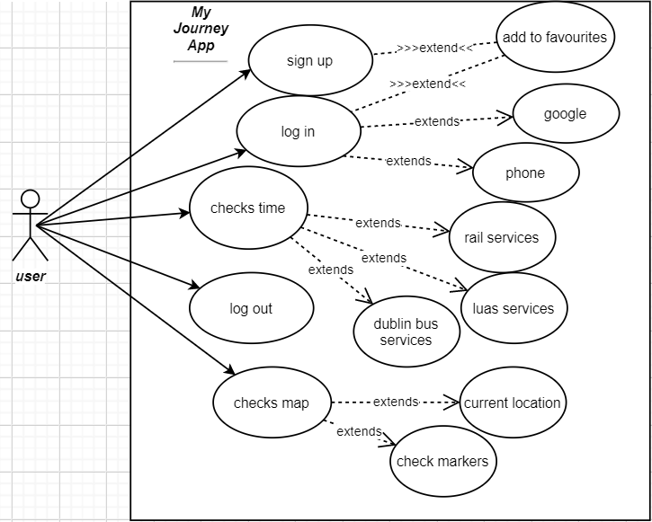

**2.2 Business actors**

Only 1 actor which is the user that will download the application onto their device to be used.

**2.2 Requirements Analysis**

**This application heavily relies on the internet as multiple requests are being sent back and forth.**

**This application relies on the internet to avoid errors connect to the WIFI.**

* **Search between varies forms of transport.**
* **Map to find current location**
* **Search places**
* **Search Origin and Destination**
* **Favorites**

**Chapter 3 – Design**

**Android Studio Navigation Editor**

Using Android Studio’s Navigation Editor, A Navigation Graph is a resource file, it contains A Host, the destinations and actions involved.

Using a bottom navigation bar, I used this with Fragment classes for my application design. Changing between destinations using actions in a much quicker and easy way. In 1 Fragment class which contains the Bus Search functionality, this destination is connected to Bus Search Result via Arguments where I pass A String – “URL” to invoke the JSON request and pass the data over to the next destination using a bundle.

I went for a simple design for all the views for simple navigation and a more enhanced user experience.

**Chapter 4 – Implementation**

**3.1. Technologies implemented**

|  |  |  |
| --- | --- | --- |
| **Technology** | **Implementation/Technology** | |
| 3 Tips to Help You Migrate to Android Studio 3.0 | SafeDK Blog | | Official IDE specifically for Android development, this was my chosen environment for the development of the application. Features of Android Studio included Emulator, Frameworks and Build Gradle system I was able to perform requirements. |
| Do I Need to Subscribe to Java SE to Run Oracle Documaker ... | | Java is chosen programming language I decided to choose to develop my application was Java as I'm more familiar with this language compared to others. |
| How to Clone Github Repo By Using Terminal | Universal Articles | | GitHub is a web-based platform used for version control; this platform was chosen for version control in the specifications for this project. It reduces the risk of source code becoming missing, it’s fast and easy to use. |
|  | | Map-box has available APIs, SDKs for developers to build a map and Navigation for your application. When using Map-Box I used the Direction API which is the Main Activity of my application. |
|  | | XML which stands for Extensible Markup Language, designed to store and transport data. Which was only used for Irish Rail XML file format, parsing with XML Pull Parser, an interface that defines parsing functionality |
|  | | Postman is an API- Client used to create, share and document API’s.  During my development I used Post-man to test API web-services etc. Irish Rail and Dublin bus. The webservice took between XML over HTTP, JSON API over HTTP. |
|  | |  |

**Chapter 4 – Implementation**

**3.2.** **Application Program Interface and Libraries implemented**

|  |  |
| --- | --- |
| **Technology** | **Description/Implementation** |
|  | The implementation of varies Map-box API’s under the following **Maps, Navigation and Search.** |
|  | To receive the RTPI REST Web Services API (RRWS API) which provides a REST interface to retrieve real time information on the 2 forms of transport, Irish Rail and Dublin Bus. |
| ncremins/luas-api  thecosmicfrog/ | [luasforecasts.rpa.ie](http://luasforecasts.rpa.ie) API endpoint, was provided by this GitHub, This API was used to grab data from the LUAS API,  I used this to complete the Luas, as it would best suit what I was achieving in terms of returning real time information of the one of most popular forms of transport in Dublin. |
|  | Volley is an HTTP Library, which enables fast networking when using Android applications. Fetching JSON data from a URL/Webservices using Volley. *parameters [GET].* |
| JSON Content, by Norbert Kuemin - Joomla Extension Directory | An Open standard file format for representing map data. Geo-JSON is a subset of the [JSON](http://www.json.org/) format. I manually had to edit these displayed on the Map-view. |
|  | JSON which stands for JavaScript Object Notation, is a standard file format which uses human-readable text to store and transmit data objects consisting of attribute value pairs and array data types. I had a choice between parsing an XML file format to a JSON and I chose JSON for the REST API for Dublin Bus using Volley |
|  | **Retrofit** is a REST Client library (Helper Library) used in **Android** and Java to create an HTTP request and also to process the HTTP response from a REST API. |
|  | |

**Chapter 4 – Implementation**

**Map Implementation**

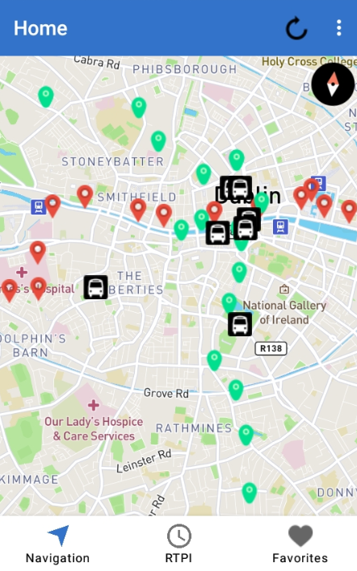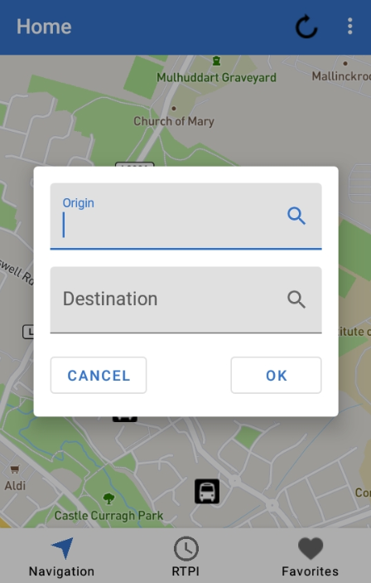

* This map returns the user’s current location.
* Tracking is enabled to get user’s movements if current location changes
* Markers are color coded Red for Red Line Luas Services, Green for Green Line Luas Services and other markers are relevant to the Dublin bus services and Irish Rail services.
* Search Dialog prompts the user to search an Origin to a Destination of their choice.
* By pressing cancelling this option can be exited.

**Chapter 4 – Implementation**

**Dublin bus services**

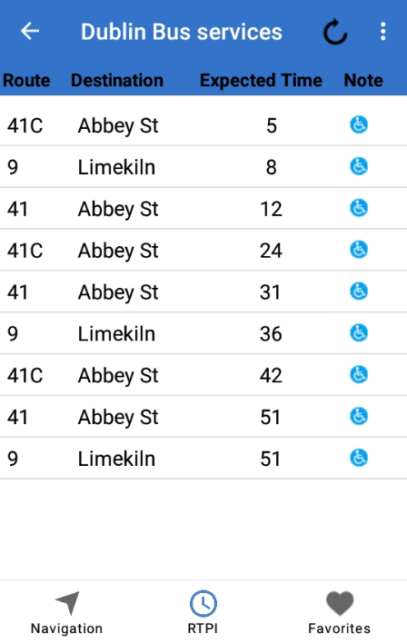

* User is prompted by a search before the screenshot above to enter a bus stop number in a textbox.
* URL is sent and it returns the relevant information – GET Request to return the values Routes, Destination, Expected Time from a webservice provided by Dublin Bus.

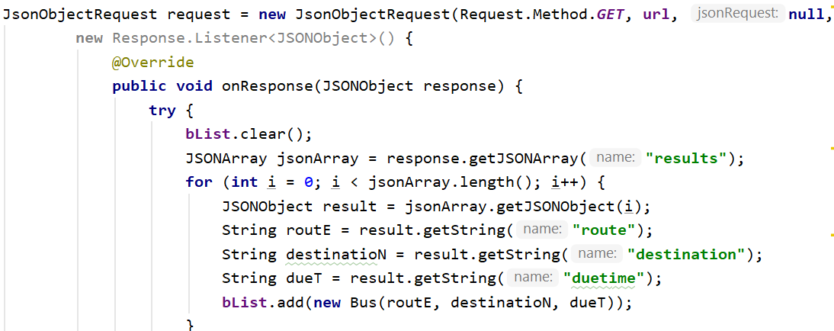

**Chapter 4 – Implementation**

**Irish Rail services and Luas services**

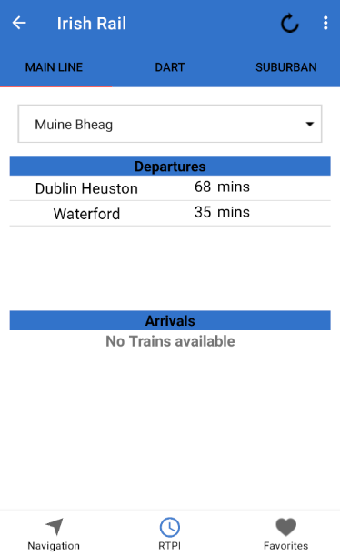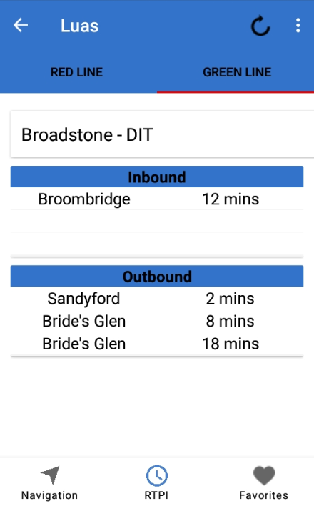

* Irish Rail services are split between each other by station type for easier navigation.
* Provided are Main-Line, Dart and Suburban.
* Using XML-Pull-Parser to parse and setting HTTP_URL_Connection data was retrieved.
* Luas Services are split between Red-Line Tram Line and Green Line Tram Lines.
* With all the stops available from both tram lines for the user to choose from.

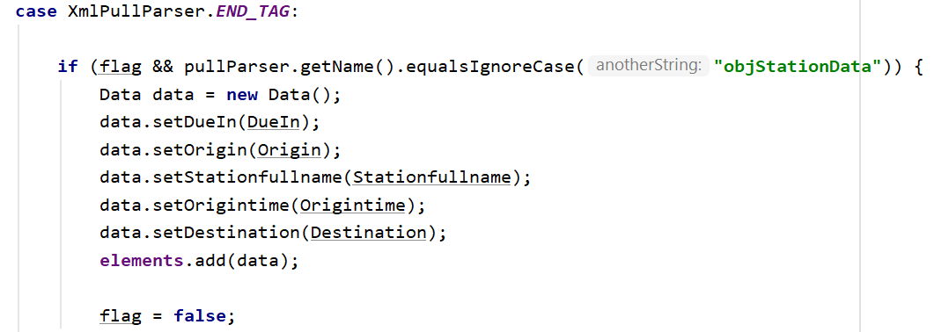

**Chapter 4 – Implementation**

**Favorites**

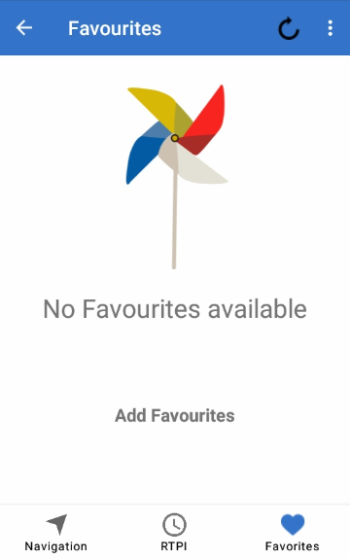

* Add and remove from favorites using Shared Preferences.
* Session Management is a better approach for my application as it’s quick and easy and the user is not forced to sign in/log in.

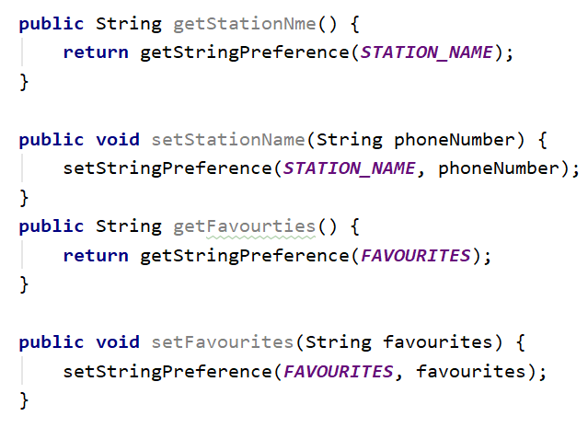

**Chapter 5 -Test Plan**

**5.1 Test Cases**

|  |  |  |  |  |
| --- | --- | --- | --- | --- |
| **Test Case** | **Test Scenario** | **Expected** | **Actual Result** | **Pass/Fail** |
| 1. | Map-box Map Directions - | Origin Search-box and Destination should give the user’s result including a poly line. |  | Fail |
| 2. | Bottom Navigation - | Moving back and forth from each navigation menu. | As expected, | Pass |
| 3. | View Real time Information – Dublin Bus | Should retrieve the chosen stop-id and display the relevant due times and bus routes available. | As expected, | Pass |
| 4. | View Real time Information – Luas Stops | Should retrieve the chosen Luas station and display the relevant incoming tram at that station | As expected, | Pass |
| 5. | View Real time Information – Irish Rail Stations | Should retrieve the chosen Rail Stations and display it in either Arrival or Departure. | As expected, | Pass |
| 6. | Favorites - | Get the chosen station/stop and put it in the list view. |  | Pass |

**Chapter 5 -Test Plan**

**5.1 Test Cases**

|  |  |  |  |  |
| --- | --- | --- | --- | --- |
| **Test Case** | **Test Scenario** | **Expected** | **Actual Result** | **Pass/Fail** |
| 8. | Markers | Markers of Luas Stop and Rail stops to appear on the map. | Expected outcome but loads slowly on an emulator. | Pass |
| 9. | Map Search | Button clicked to search just one chosen location | Search navigation appears and user can search just one location | Pass |

**Chapter 6 - References**

Jaime Martindale (2020) GIS

Available at:

https://data.gov.ie

(Accessed: 1 May 2020)

Post Man (2020)

Available at:

<https://www.postman.com/>

(Accessed: 1 May 2020)

Map box (2020)

Available at:

<https://www.mapbox.com/>

(Accessed: 1 May 2020)

W3schools (2020)

Available at:

<https://www.w3schools.com/>

(Accessed: 1 May 2020)

Android Studio (2020)

Available at:

<https://developer.android.com/>

(Accessed: 1 May 2020)

GitHub (2020)

Available at:

<https://github.com/>

(Accessed: 1 May 2020)

**Chapter 6 -References**

Geeks For Geeks (2020) GIS

Available at:

<https://www.geeksforgeeks.org/>

(Accessed: 1 May 2020)

[Gino Osahon](https://android.jlelse.eu/@ginowine1?source=post_page-----ed47aef01ecb----------------------) (2020)

Available at:

<https://android.jlelse.eu/>

(Accessed: 1 May 2020)

ncremins (2020)

Available at:

<https://github.com/>

(Accessed: 1 May 2020)